

For More Visit: [www.tekartlearning.com](http://www.tekartlearning.com/)

[Document title]

[Document subtitle]

tekule musa [Date] [Course title]

|  |  |  |
| --- | --- | --- |
|  |  |  |

## Tekart learning Hub

Table of Contents

PAPER 1 3

PAPER 2 12

PAPER 3 21

PAPER 4 30

PAPER 5 40

PAPER 6 49

PAPER 7 58

PAPER 8 66

PAPER 9 76

PAPER 10 85

PAPER 11 94

PAPER 12 102

PAPER 13 111

PAPER 14 118

## PAPER 1

1. Name any **one** domestic animal that gives us milk.
2. What deficiency disease causes swelling of the neck?
3. How do most people in the city get food?
4. Why is sugar important in **ORS**?
5. How are flowers useful to bees?
6. Why is it important to wash hands after eating food?
7. How are ears useful to a dog?
8. Which component of soil makes the soil fertile?

### The diagram below shows roots of a plant. Use it to answer question 9.

1. 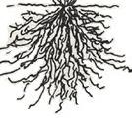Identify any **one** plant with such roots.
2. Give any **one** danger of diseases to people.
3. Write **one** way farmers can stop rats from destroying stored food.
4. How are termites similar to wasps in the way they live?
5. Give **one** way of controlling houseflies at home.
6. What is the importance of a micopyle to a bean seed?
7. Which food value is needed most by people who make bricks?
8. Why do first aiders need a first aid box?
9. How can P.4 children keep their classroom clean?
10. Give **one** importance of banana fibres to school children.
11. Why is it important for people to preserve food?
12. Give the importance of the item below to a school child.

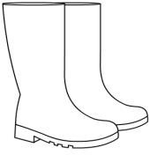

1. Write **one** effect of drought to people.
2. Give any **one** way of killing germs and vectors in our clothes.
3. Name any **one** childhood immunisable disease in our community.

### The diagram below shows a human body organ. Use it to answer questions 25 and 26.

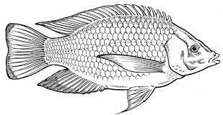

1. Name the body organ shown above.
2. Give any **one** function of the above part of the body.
3. Why do some schools have gardens?
4. Which instrument is used by health workers to find the body temperature of a patient?
5. Name any **one** natural change in the environment.
6. Identify **one** group of people who control the flow of traffic on our roads.
7. Why should people eat a balanced diet?

### The diagram below shows a common animal. Use it to answer question 31.

**X**

1. How is part **X** useful to the animal above?
2. Draw and name a garden tool used for peeling.
3. Give the difference between air and wind.
4. Write **one** way of saving energy at home.
5. State any **one** way of caring for toilets at school.
6. Which sense enables people to tell that there is sugar in tea?
7. How is the item below useful to people?

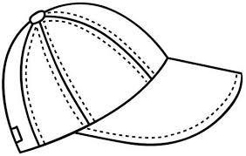

1. Why do dogs move from one place to another?
2. Give the importance of earthworms in the soil.
3. Name any **one** local material that is used to build permanent houses.

### SECTION B:

1. (a) Give any **two** dangers of accidents to people.

(b) State **two** ways in which people can prevent accidents at home.

(i)

(ii)

1. (a) How many teeth make up the first set?
2. Give the function of teeth when eating food.
3. Name any **one** disorder of teeth.
4. State **one** way people at home can take care of their teeth.
5. (a) What is photosynthesis?
6. Which part of a plant carries out photosynthesis?
7. How is chlorophyll important during photosynthesis?
8. Apart from photosynthesis, name one other process that takes place in plants.
9. (a) Write any **two** processes involved in the formation of rain. (i)

(ii)

1. How is too much rainfall dangerous to our environment?
2. Give the function of the sun in rain formation.
3. (a) Write any **two** diseases that result from poor feeding. (i)

(ii)

1. Give **one** sign of poor feeding among children.
2. Identify any **one** way people in your family get food.

### The diagram below shows a life cycle of a butterfly. Use it to answer question

**L**

1. (a) Name stage marked **L** on the diagram above.

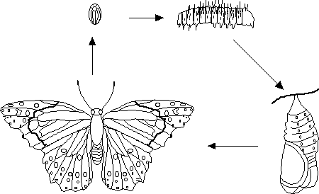

**46.**

**N**

**K**

**M**

1. How is stage **N** dangerous to people?
2. Which of the stages above is useful to farmers?
3. Identify any other insect that undergoes a life cycle like the one above.
4. (a) Write any **two** ways water gets contaminated at home. (i)

(ii)

1. Give **one** danger of drinking contaminated water.
2. Identify any **one** method you would use to make water safe for drinking.
3. (a) What is fuel?
4. Name any **two** fuels commonly found in the kitchen. (i)

(ii)

1. Write any **one** way of saving energy at home.
2. (a) Give any **one** example of a wild bird.
3. Name any **one** domestic animal which does not give us meat.
4. Write any **two** ways of caring for domestic animals. (i)

(ii)

1. (a) Name the second layer of soil profile.
2. Why is top soil suitable for plant growth?
3. Identify any **two** human activities that can damage soil. (i)

(ii)

1. (a) How is **AIDS** dangerous to people?
2. Give **two** ways of caring for **AIDS** patients. (i)

(ii)

1. Identify any **one** way pupils can protect themselves from **HIV/AIDS**.

### Image result for local plant sponge used for bathingThe diagrams below show items used to keep our bodies clean. Use them to answer question 52.

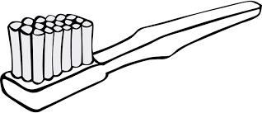

**A B C**

1. (a) Name any **one** part of the body that is cared for using item marked **C**.
2. Write any **one** hygiene activity that is done using item marked **A**.
3. How is item **B** useful to people?
4. Identify any **one** source of item marked **A**.

### Match the part of a flower to the correct function.

**Part function**

* 1. stigma - produce pollen grains.
  2. ovary - attract pollinators.
  3. anthers - holds the ovules.
  4. petals - receives pollen grains.

1. stigma
2. ovary
3. anthers
4. petals
5. (a) Give the function of the following weather instruments.
   1. wind vane -
   2. anemometer -
6. Why should a rain gauge be placed in an open place?
7. Write any **one** activity that farmers can do in windy weather.

### The experiment below was carried out by P.4 pupils. Use it to answer questions that follow.

**glass**



### candle

1. What is the experiment about?
2. What will happen to the candle after some time?
3. Name any other process that uses the same gas as burning.
4. Which gas can be used to stop things from burning?

# PAPER 2

1. Give any **one** infant immunisable disease.
2. What is the use of earthworms in the soil?
3. In which way are teeth useful during digestion of food?
4. Which type of seeds undergoes epigeal germination?

**The diagram below shows a plant.**

**S**

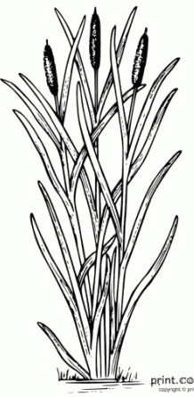

1. Of what use is structure marked **S** to the plant?
2. Why does sand soil easily lose water?
3. Give any **one** advantage of weeding to farmers.
4. How can you help in saving electricity at home and school?
5. Why is a mosquito grouped under living things?
6. In which **one** way can you help to improve soil fertility?

**The diagram below shows the head of a bird.**

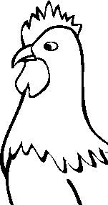

1. By use of an arrow, show the wattle.
2. How do plants like mangoes reduce their rate of transpiration during the dry season?
3. Why is a shed put at the top of a nursery bed?
4. Name the human body organ where urine is stored before it is removed from the body.
5. Why is massive cutting down of trees dangerous to our environment?
6. Why would you advise poultry farmers using free range not to live near forests?
7. Give any **one** danger you may get for failing to wash your clothes.
8. In which **one** way can you help in controlling diarrhea at home?

**The diagram below shows a kettle with boiling water.**

**K**



1. Name the substance labeled **K**.
2. Which form of energy leads to formation of substance **K**?
3. Name any **one** disease spread by a vector that feeds on faeces.
4. Give **one** danger of polio to infants.
5. How do children get infected with worms?
6. Name any **one** type of poultry.
7. **Calculate the volume of the figure below.**

**3cm**

**2cm**

**4cm**

1. Why do people eat food?
2. Why are people discouraged from carelessly playing with razor blades?
3. Give any **one** natural change in the environment.
4. **In the space below, draw a whole bean seed and show the seed coat.**
5. How can you separate passion fruit juice from its seeds?
6. Name the kind of honey bee commonly found near flowers.
7. Why is it dangerous to keep poison in open places at home?
8. How do farmers care for their crops during drought?
9. **Draw the item in which rubbish is disposed in the classroom.**
10. Give any **one** advantage of keeping records to farmers.
11. How do farmers control crop pests in their gardens?
12. In which **one** way can children and their teachers use shadows in their environment.
13. In which way is a nuclear family different from an extended family.
14. How can crop farmers make good use of wind?
15. Why do animals make movements?

**SECTION B**

* 1. Name any **two** examples of domestic animals.

b) Give any **two** insects eaten by people.

3. 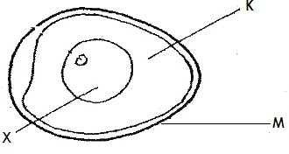**The diagram below shows internal parts of an egg. Use it to answer questions that follow.**
   1. Name the part labeled **K** and **X**

**K X**

* 1. By use of an arrow ( ) and letter **P**, show the part that develops into a chick.
  2. How is structure labelled **M** useful to poultry farmers?
  3. Identify any **two** breeds of rabbits

1. Name any **one** disease that affects the above animals.
2. How do farmers control rabbit diseases?
3. **Re-arrange the following sentences to describe the order (steps) involved in rain formation.**
   1. The nimbus clouds become heavy and fall as rain.
   2. Evaporation and transpiration takes place.
   3. Water vapour rises up and condenses to form nimbus clouds.
   4. The sun heats water in lakes and the vegetation.

1.

2.

3.

4.

1. **The diagram below shows an experiment which was carried out by P.3 pupil’s. Use it to answer questions that follow.**

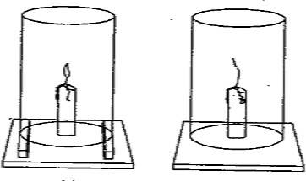

**glass**

**X Y Z**

1. Which component of air supports the process in **X**?
2. Why did the candle continue burning in **Y**?
3. Why did the candle stop burning as shown in **Z**?
4. What does the above experiment show about air?
5. a) Write **ORS** in full.
6. Mention **one** solute used in making of **ORS**.
7. How is **ORS** useful to a person suffering from diarrhea?
8. Why is it important to wash hands before preparing **ORS** locally?
9. a) What is photosynthesis?
10. Name any **one** raw material needed by plants to carry out photosynthesis.
11. Write the food made by plants during photosynthesis.
12. Name the gas released by plants during photosynthesis.
13. **The diagram below shows parts of the human digestive system.**

**F**

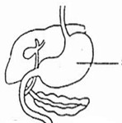

**E**

**G**

1. Name the parts labelled **G** and **E**.

**G E**

1. In which way is part **F** useful during digestion?
2. How can you improve on the normal functioning of your digestive system?
3. Mention any **two** items found in a first aid box.

6. Why are causalities taken to hospitals or health centres?
7. How can you assist your friend who has fallen in a pit latrine?
8. **The table below is a weather chart. Use it to answer questions that follow.**

|  |  |
| --- | --- |
| **A** | **B** |
| **C**  Description: Related image | **D** |

1. 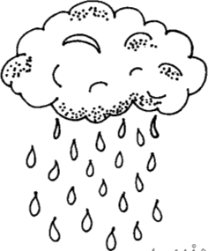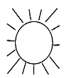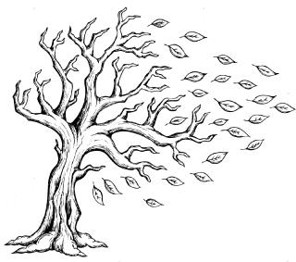Write **one** crop farming activity that may be carried out in conditions **A** and **C** above.
2. **A**
3. **C**
4. Which weather condition is suitable for winnowing?

_

1. Give the advantage of weather condition **D** to our environment.
2. **The diagram below shows a garden tool.**

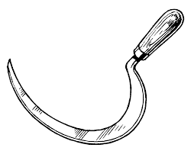

1. Identify the garden tool shown above.
2. How is the above garden tool useful to farmers?
3. How do you care for such garden tools at home?

6. **Match the following vectors to the diseases they spread correctly.**

Vector disease

Tsetse fly plague

Housefly malaria

Female anopheles mosquito sleeping sickness

Rat fleas bilharzias

Cholera

1. Tsetse fly
2. Housefly
3. Female anopheles mosquito
4. Rat fleas

53.a) Write any **one** food stuff rich in carbohydrates.

1. Which deficiency disease can a child suffer from if he / she lacks enough carbohydrates.
2. Apart from carbohydrates, name other **two** food values required in our bodies.

54.a) What is soil erosion?

1. Mention any **one** cause of soil erosion.
2. How can erosion be controlled in the following areas?
3. school compound
4. a garden on a hilly land
5. **The diagram below shows a method used in measuring objects.**

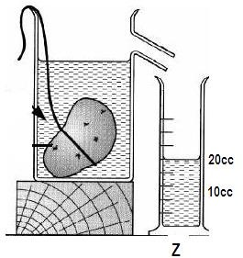

* 1. Which kind of objects are measured using the method shown above?
  2. Name container marked **Z**.
  3. If the stone has a density of 3g/cc. calculate its mass **(2 marks)**

1. Name **one** faecal disease.

# PAPER 3

1. Give **one** way a P.5 child can prepare eggs for eating.
2. State any **one** role of a mother in a home.
3. How are grasshoppers dangerous to farmers?
4. Write any **one** use of banana fibres at school.
5. How useful is the item drawn below to people at home?

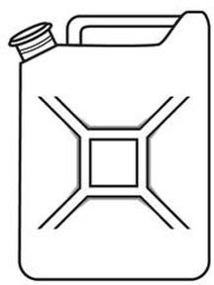

1. Name the body organ used for seeing.
2. Give any **one** source of water.
3. Which part of a plant is used for sucking water from the ground?
4. Identify **one** animal at home that produces milk.
5. Why are some metallic tools painted?
6. Which gas is needed by plants during photosynthesis?
7. Give **one** use of shadows to people.
8. How can you prevent tape worm infection?
9. Name the type of soil which is rough and with large particles.
10. State any **one** danger of strong wind.
11. Name any **one** agent of soil erosion.
12. State any **one** danger of not brushing your teeth after every meal.
13. Why does a stone sink when thrown in water?
14. Identify **one** characteristic of an insect.
15. How is the garden tool below useful to farmers?



1. How many legs has a spider?
2. Name **one** harmful plant in the environment.

### Draw a diagram to show that air occupies space.

1. Give **one** example of a perennial crop.
2. Name **one** vector that breeds in water.

_

1. Name any **one** thing made out of clay at home.
2. Give the use of the body organ marked **Y** on the diagram below.

### Y

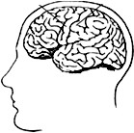

1. In which way are rats dangerous to people?
2. State **one** danger of electricity in our homes.
3. Give any **one** use of food in our body.
4. Why is it important to cross the road carefully?
5. Give any **one** use of a school garden.
6. State any **one** way of caring for crops in the garden.
7. Give **one** way people can control the spread of dysentery in the community.

### The diagram below shows an animal.



How does the animal above move from one place to another?

1. Why should rabbit hutches be cleaned regularly?
2. Name the weather instrument used to measure the amount of rain received in an area.
3. Identify **one** component of air.
4. Give **one** way a P.4 child can prevent him/herself from getting AIDS.

### SECTION B

1. (a) What is weather?
   1. Name the element of weather which people use to;
2. water their crops?
3. winnow harvested crops?
   1. Name **one** material used to manage weather.

### Below is a food store. Use it to answer question 42.

**W**

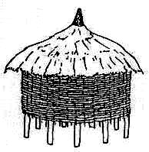

**Y**

1. (a) Name the food store shown above.
2. Write **one** material used to make the above store.
3. Name part marked **W**.
4. How is part marked **Y** useful on the food store.
5. (a) What is wind?
6. How can wind be useful to people? (i)

(ii)

1. In which way is wind dangerous to people?

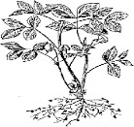

### The diagram below shows a method of planting. Use it to answer question 44.

1. (a) Name the above method of planting.
2. Write down any **two** advantages of using the above method of planting. (i)

(ii)

1. Apart from the above method, write **one** other method of planting.
2. (a) What is an extended family?
3. Name any **two** groups of people found in an extended family. (i)

(ii)

1. Give **one** way in which a nuclear family can become an extended family.

### The diagram below show a split bean seed. Use it to answer question 46.

**P**

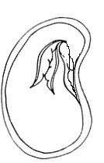

**Q**

### R

1. (a) Name parts marked **Q** and **R**.

### Q R

1. Give the function of part marked **P**.
2. Which type of germination does the bean seed above undergo?

### Match the animals in A with their habitats in B correctly. Animal Habitat

Bird Hutch

Dog Nest

Rabbit Kraal

Cow Kennel

* 1. Bird
  2. Dog
  3. Rabbit
  4. Cow

### Below is a diagram of a human tooth. Use it to answer question 48.

**M**

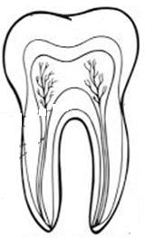

### P

**Q**

1. (a) Name the type of tooth drawn above.
2. Name the region marked **M**.
3. How is the above tooth useful when eating?
4. State any one way in which people can protect their teeth from

|  |  |  |
| --- | --- | --- |
|  | | decay. |
| 49. | (a)  (i) | Name any **two** sources of food. |
|  | (ii) |  |
|  | (b) | Which food value is obtained from eating fruits? |
|  | (c) | Which deficiency disease is as a result of lack of carbohydrates in the body? |
| 50. | (a)  (i) | Give any **two** components of the first aid box. |
|  | (ii) |  |
|  | (b)  (i) | State **two** reasons why first aid should be given. |
|  | (ii) |  |
| 51. | (a) | Give **two** examples of wood fuel used at home. |
|  | (i) |  |
|  | (ii) |  |

1. Write down **one** use of paraffin at home.
2. Give any **one** use of the sun.

### Use the words below to fill in the passage below correctly.

**rain , condenses , heats , atmosphere**

The sun the water causing evaporation to take place. The water vapour rises to the . The water vapour

to form clouds. The clouds become heavy and begin to fall as .

### The diagram below shows a life cycle of a cockroach. Use it to answer

**question 53. A**

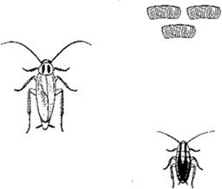

**C**

**B**

1. (a) Name the stages marked **A** and **B.**

### A B

1. Apart from a cockroach, name any other insect that undergoes the above life cycle.
2. Give any **one** danger of cockroaches at home.
3. (a) Identify **two** causes of dehydration.

(c) State any **two** signs of dehydration in children.

3. (a) How do the following animals protect themselves?
   1. Dog:
   2. Chameleon:
4. Give **two** uses of wild animals to people.
6. _

# PAPER 4

1. Name any **one** part of the human body organ that is found on the head.
2. Give **one** way family members may care for an HIV/AIDS patient?
3. Give any **one** example of an annual crop.
4. Mention any **one** component of soil.
5. State **one** importance of keeping our bodies clean.
6. In the space below, draw a diagram to show that air exerts pressure.
7. Name the disease vector that spreads malaria.
8. Write down any **one** danger of the sun.
9. Identify any **one** example of a natural change in the environment.
10. Apart from a hen, name **one** other domestic bird.
11. Give **one** way people can care for insects such as bees.

**The diagram below shows a soil profile. Use it to answer questions 12 and 13.**

### plants

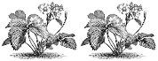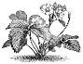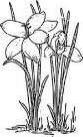

**X**

1. Identify the layer marked **X**.
2. Using an arrow, show the layer that contains a lot of humus.
3. Give **one** way of keeping food free from germs.
4. State the importance of a dog to people in a home.

### The diagram below shows a garden tool.

How do people care for the above garden tool?

1. Name any **one** example of an insect without wings.
2. State any **one** way of controlling pests in a garden.
3. Name any **one** living component in the environment.
4. In which way is clearing bushes near your home useful to family members?
5. In which way is cutting down of trees a danger to the environment?
6. Draw any **one** item used to keep our bodies clean.
7. State **one** disadvantage of heavy rainfall to people.
8. Mention any **one** local material made from banana fibres.
9. Give any **one** example of a domestic bird.
10. State the importance of grasshoppers to people.
11. Give **one** way of avoiding accidents at home.
12. What type of germination does a bean seed undergo?
13. Give **one** way of avoiding accidents at home.
14. Mr. Kalumbe’s family has parents, grandparents and biological children. Which

kind of family is this?

1. Which animal stays in the habitat shown below?
2. Identify any **one** common sign of a crop damaged by pests.
3. To what class of food does cassava belong?
4. Give any **one** way of caring for wild animals.
5. Why should you group a maize plant under living things?
6. Apart from the sun, give any other natural source of energy.
7. Mention any **one** childhood immunisable disease.
8. Why do you group tomatoes under annual crops?
9. State any **one** activity where clay soil is used as a raw-material.
10. Give any **one** use of a cow to people at home.

### SECTION B

1. (a) How do we call a meal that contains all food values in their correct amount?
   1. Mention any **two** classes of food that make up a balanced diet.
3. 1. What food value do we get from eating beans?

### The diagram below shows a fish. Use it to answer questions that follow.

**A B**

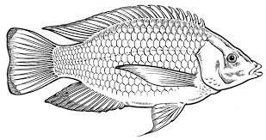

* 1. Name the parts labeled with letter **A** and **B**.

### A B

* 1. Using an arrow on the diagram, show the part used for smelling food in water.
  2. Give any **one** use of fish to people.

1. (a) Name any **two** common accidents at home.

4. Mention any **one** cause of accidents at home.
5. What first aid is given to someone with burns?

### Match the garden tools in A to their uses in B correctly. A B

Wheelbarrow - splitting firewood.

Watering can - breaking stony and hard soil. Forked hoe - carrying rubbish and manure.

Axe - watering plants.

1. Wheelbarrow
2. Watering can
3. Forked hoe
4. Axe
5. a) Name any **one** source of water in our community.
   * 1. Give any **one** use of water to people.
     2. Write any **one** way of making water safe for drinking.
     3. Give any **one** danger of having stagnant water near our homes.

### The diagram below shows the shoot system of a flowering plant. Use it to answer the following questions.

**C**

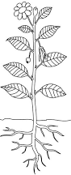

**A**

### B

1. Name the parts of the shoot labeled with letters **A** and **C**.

### A C

1. Give **two** uses of part **B** to a plant.

### The diagram below shows the life cycle of a cockroach.

**EGGS**

**NYMPH**

* 1. Complete the life cycle of a cockroach above.
  2. Name the type of lifecycle shown above.
  3. Apart from the life cycle above, mention **one** other type of insect life cycle.

1. (a) What are domestic animals?
2. Give **two** examples of domestic animals that provide people with milk.

5. Give any **one** way people can care for their domestic animals.
6. A house is a building that is lived in by a family.
   1. Name any **two** materials used in building a house.
8. 1. Give any **two** places where people can get building materials.

11. (a) In **one** sentence , write the meaning of personal hygiene.
12. Identify any **two** things we use to promote personal hygiene.

15. State any **one** importance of personal hygiene.

### The diagram below shows a natural change in the atmosphere. Study it and answer the questions that follow.

**plants**

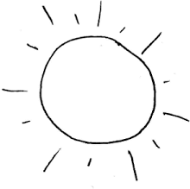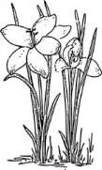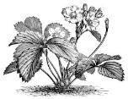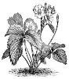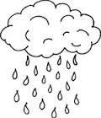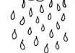

**C**

**B**

**LAND**

**A**

* 1. What name is given to the natural change shown above?
  2. Name the processes that take place at **B** and **C**.

|  |  |  |
| --- | --- | --- |
|  | **B** |  |
| **C**  (c) | How are plants useful in the natural change above? |
| 53. | (a) | Briefly explain the term mulching. |

1. Why do farmers mulch their gardens?

4. How can mulching be a danger to crops in the garden?

### The figure below shows a weather chart. Use it to answer questions that follow.

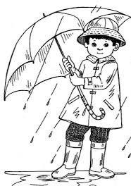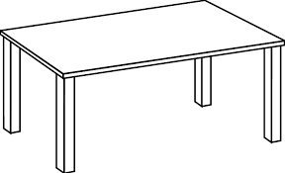

**B**

**A**

* 1. Identify the types of weather shown in **A** and **B**.

### A

1. **B** 
   1. Give any **one** way in which the type of weather in **B** is useful to a crop farmer.
   2. State **one** way of protecting ourselves from weather **B**.

### Complete the table below correctly.

|  |  |  |
| --- | --- | --- |
| **Food value** | **Source** | **Use in the body** |
|  | mangoes | Keeps the body healthy |
| proteins |  | Builds the body |
| carbohydrates |  |  |

1. **Re-arrange the following steps of making O.R.S correctly.**

Stir until all the salt and sugar dissolve. Wash your hands with clean water and soap.

Measure one litre of drinking water into a clean container.

Measure one leveled teaspoonful of salt and eight of sugar into the drinking water.



# PAPER 5

1. Name any **one** staple food that is processed using a mortar and a pestle.
2. Give any **one** material that people may use to clean their teeth.
3. How do farmers protect their crops from being destroyed by drought?
4. Give any **one** way of preventing faecal diseases at school.
5. Why do people put scare crows in their gardens?
6. In which way is a leopard dangerous to people?
7. Name the living component of the environment which gives us timber.
8. Identify any **one** natural factor that destroys our environment.

### Draw and name a tool you can use to clean a house.

1. How are forests useful to birds?
2. How do people control malaria in their homes?
3. How is heavy rainfall dangerous to people?
4. Mention any **one** social insect.
5. Name **one** plant that gives us fibre for making balls.
6. How do people prevent spread of **HIV**/**AIDS** in their communities?
7. State any **one** source of heat energy in our environment.
8. Identify any **one** area in a home that requires constant cleaning.
9. Name any **one** other relative in an extended family.
10. Which type of weather encourages people to wear sweaters?
11. Identify any **one** immunisable disease.

### The diagram below shows part of a flower.

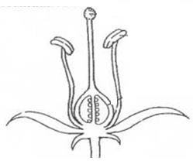

1. Use an arrow and letter **Z** to show the stigma.
2. Give any **one** role of a mother at home.
3. Why do farmers mulch their gardens?
4. Give any **one** animal which lives in soil.
5. Why are bean plants grouped under flowering plants?
6. Name any **one** material that people use to keep the toilets clean.
7. Give any **one** use of soap at school.
8. State any **one** way of controlling the spread of malaria at home.
9. State any **one** way of preventing skin diseases.

### Draw a garden tool used for cutting trees.

1. State **one** importance of eating a balanced diet.
2. Give any **one** use of skins and hides of animals to people.
3. How can injuries of cuts be prevented at home?
4. Where do houseflies lay their eggs?

### The diagram below shows roots of plants.

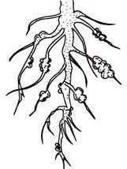

1. Name **one** plant with the kind of roots shown above.
2. A kitten is a young one of a domestic animal. Name that animal.
3. Why is it important for school children to wear shoes?

### Complete the life cycle.

**Adult**

**Eggs**

1. Give any **one** use of carbon dioxide.
2. Name any **one** plant that has thorns on its stem or leaves.

### SECTION B

1. (a) Apart from water, give any other **two** components of soil.
2. Name **one** farming practice that can keep water (moisture) in the soil.
3. Give any **one** use of water at home.
4. (a) Why do people preserve food?
5. Apart from refrigeration, give **two** other ways of preserving food. (i)

(ii)

1. Why is refrigeration not common in rural areas?
2. (a) Name the sense organ for tasting.
3. Give **one** way of caring for the organ you have named in (a) above.
4. Write **two** other senses in the human body. (i)

(ii)

1. (a) Match the types of weather in **A** to the correct activities in **B**.

### A B

Rainy weather winnowing seeds

Windy weather drying harvested crops

Sunny weather harvesting water

* 1. Rainy weather
  2. Windy weather
  3. Sunny weather

(b) Which of the above types of weather can we manage by putting on gumboots?

1. a) Which month in a year has the least number of days.
2. Name the season in which farmers plant their seeds.

### Study the rectangle below.

**3 cm**

**7 cm**

What is the length and width of the rectangle?

1. Length
2. Width

### Image result for images of a sugarcaneThe diagram below shows foodstuffs. Use it to answer the question below.

|  |  |
| --- | --- |
| **A**  C:\Users\pc\Desktop\images\mago.jpg | **B** |

1. Name the food stuff marked **B**.
2. Identify the food value got from foodstuff marked **A.**
3. Write **one** tool that can be used to peel foodstuff **B** for eating.
4. Why should foodstuff **A** be washed properly before eating it?
5. (a) How do the following animals protect themselves from enemies?
   1. Chameleon
   2. Dog
   3. Hen

(b) Write any **one** way domestic animals can be dangerous to people.

### The digram below shows an item in a first aid box.

Plaster

1. Give the use of this item in giving first aid.
2. Identify any **one** quality of a good first aider.
3. State any **two** reasons for giving first aid to people who have got accidents.

(i) (ii)

1. (a) Name the disease caused by **HIV.**
2. How is **HIV** spread from one person to another?
3. Give **one** way a school child can protect him / herself from getting **HIV.**

d) Write any **one** way of caring for people with **HIV**.

1. (a) Give **two** uses of shadows to people. (i)

(ii)

1. In which direction will the shadow of an object be if the sun is in the West?
2. At what time of the day are shadows shortest?

### (a) Name the garden tools below.

|  |  |
| --- | --- |
|  | C:\Users\pc\Desktop\images\503277654.jpg |
|  |  |

(b) Name any **one** tool which can be cared for by;

1. sharpening:
2. oiling moving parts:
3. (a) How are the following useful in the water cycle?
   1. The sun
   2. Trees
4. Name **one** human activity which can affect the water cycle.
5. Write **one** way people can make use of rainwater.

### Fill in the gaps with the correct words.

Germination is the development of a seed into a . There are two types of germination namely hypogeal germination and

germination.

During germination, seeds need to soften the testa for the embryo to come out. The radicle of a seed develops into the root system and the develops into the shoot system.

1. (a) Name any **one** material / thing found in a bedroom.
2. Identify **two** ways of caring for our beddings. (i)

(ii)

1. Name **one** parasite that can come to our beds if they are not cleaned well.

### The diagram below shows a fish. Use it to answer question 55.

**A**

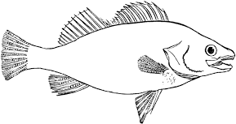

**C**

**B**

1. Name the parts marked **A** and **C**. **A**

### C

1. Use letter **D** to show the part that protects the gills.
2. Give **one** use of fish to people.

# PAPER 6

1. Name the part of the body used for smelling.
2. Give any **one** way of preparing cassava before eating.
3. Why do bees visit flowers?
4. Why do we iron clothes before wearing them?

### Draw a diagram of a simple leaf in the space below.

1. Name the gas used to put out fire.
2. State any **one** role of children in a home.
3. How are earthworms important in the soil?
4. “It refers to the general cleanliness of the place where we leave.” Write **one** word for the above statement.
5. How is fire useful at school?
6. Write down any **one** use of sisal material at school.
7. Joan likes sharing sharp body cutting objects with her friends. How is this

practice dangerous to their health?

1. Which human organ has the same function as the gills of a fish?
2. How can you control the spread of diarrhea at home?

### The diagram below shows parts of an egg. Use it to answer questions 15 and 16.

**X**

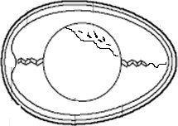

### Y

1. Name part marked **X** on the diagram above.
2. Identify **one** animal at home that produces eggs.
3. In which way can windy weather be helpful to people?
4. Why are some metallic tools painted?
5. What happens to water when it is heated?
6. Write any **one** use of food in the body.
7. Why is it dangerous to cross the road carelessly?

### The diagram below shows a cabbage plant. Use it to answer question 22.

B

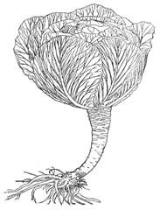

1. How is part labeled **B** useful to people?
2. Name the gas given off by plants during photosynthesis.
3. Write any **one** material used for constructing a permanent house.

### Draw the shadow of the object below in the right position.



1. Name any **one** foodstuff we get from a lake.
2. By what process are nimbus clouds formed?
3. Why do people lock their houses at night?
4. What is wind?
5. Which part of a bean seed stores food?
6. Why is it bad to share a towel with other people?
7. Write **one** way you can save energy at home.
8. How can you help a person who is dehydrated?

### Fill in the missing stage.

**Egg**

**larva**

**adult**

1. Give any **one** way you can care for insects like bees.
2. Identify any **one** health habit you can teach your young brother or sister to do.
3. How can you prevent worms from entering your body?
4. Give any **one** way people make use of rain water.
5. What advice can you give to a person who has lice in the hair?
6. What does the experiment below prove about soil?

**bubbles**

### water lump of soil



**SECTION B**

### Match items in list A with those in list B. A B

Forked hoe transplanting seedlings

Knapsack sprayer improve on soil fertility

Trowel spraying herbicides

Fertilizers digging hard ground

* 1. Forked hoe
  2. Knapsack sprayer
  3. Trowel
  4. Fertilizers

1. a) Name any **two** materials used in cleaning our bodies.

4. Give **one** disease that we get due to poor personal hygiene.
5. How can you promote personal hygiene?
6. a) Give any **one** way we can make water safe for drinking?
7. Write any **two** ways in which water sources may get contaminated.

10. Name any **one** natural source of water.

### The diagram below shows part of the human body. Use it to answer question 44.

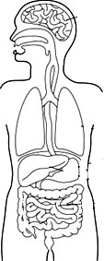

**T**

### R S

* 1. Name the body organs marked **T** and **S**.

### T S

* 1. Give any **one** use of organ marked **T.**
  2. How can you care for the organ marked **R** above?

1. a) State any **two** reasons for giving first aid to accident victims.

b) Write any **two** items that are found in a first aid box.



### The diagram below is of a food store found in village homes. Use it to answer the questions below

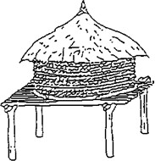

**K**

* 1. Name the food store shown above.
  2. How are structures marked **K** important on the food store above?
  3. Identify any **two** crops that can be stored in the food store above.

3. a) Give any **two** food values that make up a balanced diet.

b) Write any **two** diseases caused by poor feeding.



### The diagram below shows part of a plant. Use it to answer the questions that follow.

* 1. Name the part of the plant shown above.

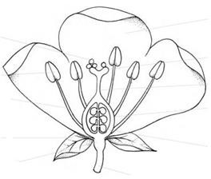

**X**

**V**

**W**

* 1. What is the importance of the part shown above to a plant?
  2. Name part marked **V** and **X** on the diagram above.

### V X

1. a) Write **two** insects which are useful to people.

4. State any **one** danger of insects to people.
5. Identify any **one** characteristic of insects.
6. a) Name the part of a fish which it uses for:
7. smelling
8. breathing (iii)feeding

b) Give any **one** reason why people catch fish.

### The diagram below shows a tooth. Use it to answer the questions that follow.

**neck**



**B**

**C**

* 1. Name the part marked **B** and **C.**

### B

1. **C** 
   1. Which part of a tooth is the hardest?
   2. How is the tooth in the diagram above useful to people?
2. Apart from extended family, name any other type of family in your area.

b) Write any **two** groups of people found in an extended family.

3. Give the member of a family who breast feeds the baby at home.
4. a) Give any **two** examples of pests that attack crops in the garden

7. How can you control pests in a crop garden?

### https://s-media-cache-ak0.pinimg.com/236x/14/cd/16/14cd165fa79e596f5923068b4a84353e.jpgThe picture below shows a health facility in our area. Use it to answer the questions below.

1. Identify any **two** groups of people that work in the above facility.

4. Which group of people are carried to the facility above?
5. Write any **one** way you would take care of a person who is in the facility above.

### a) Draw and name any two materials used in cleaning kitchen utensils.

|  |  |
| --- | --- |
|  |  |
|  |  |

1. Write **one** danger of eating food from dirty plates.
2. Give any **one** way you can keep the kitchen clean.

# PAPER 7

1. Name any **one** component of soil.
2. Which part of the human body is used for feeling?
3. Why is a bean plant grouped under flowering plants?
4. How can you control soil erosion in a school compound?
5. Why are garden tools kept in cool dry places after use?

### The diagram below is of a human tooth. Study it and answer question number 6.

1. Name the above tooth.



1. Write **ORS** in full.
2. How is heavy rainfall dangerous to people?
3. How are foods rich in proteins important to a seven year old boy?
4. Why should we cover leftover food at home?
5. Why should we keep our bodies clean?
6. Give any **one** use of water at home.
7. Why is the heart important in the human body?

### The diagram below is of a bird. Use it to answer question 14 and 15.

1. Name part marked with letter **Y**.

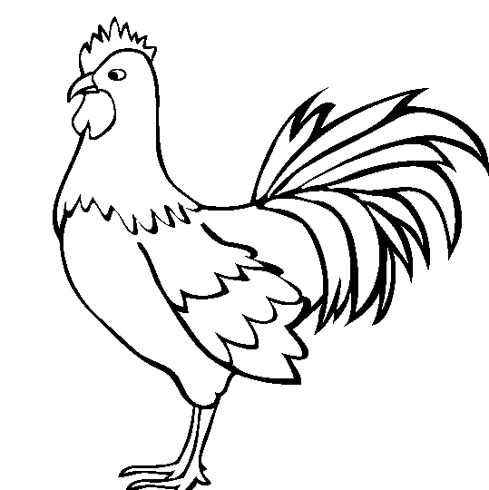

**Y**

1. By use of an arrow and letter **X**, show the part which is used to pick food.
2. Give any **one** way a P.2 child can cross a busy road safely.

### In the space below, draw one item used to manage sunny weather.

1. Name any **one** disease that we can control by boiling water for drinking at home.
2. State the first aid for a burn.

### In the space provided below, draw a diagram to show network leaf venation.

1. Looking at the watery stool of a patient, how can you tell that the person has dysentery?
2. How are stars useful to people?
3. Why should people close doors and windows early in the evening?
4. How are rat guards useful on a granary?
5. Why is it dangerous to stay with domestic animals in the same house?
6. Give the importance of chlorophyll during photosynthesis.
7. Give any **one** use of electricity at home.
8. Mention any **one** use of carbon dioxide to people.
9. Give any **one** way people use bricks in our community.
10. Name the staple food drawn below.

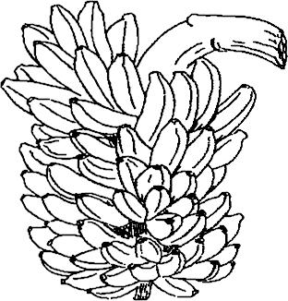

1. Why should every classroom have a dustbin?
2. How do farmers preserve maize after harvesting?
3. State any **one** way in which people may damage the environment.
4. Give any **one** way we can care for our eyes.
5. How is the structure below useful to a spider?

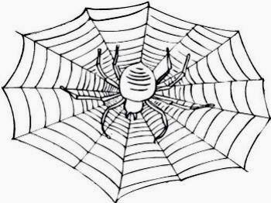

1. State any **one** way of controlling the spread of germs at home.
2. How are plants useful to animals?
3. Draw the garden tool used to harvest cereals.
4. What is soil erosion?
5. Write down any **one** item that can be used in water harvesting at home.

### SECTION B

1. (a) State any **two** ways of maintaining proper sanitation at home.

(b) Name any **two** diseases that can be spread through poor sanitation.

|  |  |  |
| --- | --- | --- |
|  | (i) |  |
| (ii) |  |
| 97. | (a)  (i)  (ii)  (b) | What do the following worms feed on in the human body?  Hook worms Tape worms Besides the above worms, mention **one** other worm which affects the human body. |
|  | (c) | How can worms be prevented? |
| 98. | (a) | What is a resource? |
|  |  |  |
|  | (b) | State any **one** use of electricity at home. |
|  | (c) | How can electricity be dangerous to people at home? |
|  | (d) | State **one** way of saving electricity as an energy resource. |
| 99. | (a) | How do we use the item below at home?  Image result for razor blade outline |
|  | (b) | Why do we brush our teeth after every meal? |
|  | (c)  (i) | Name any **two** diseases spread as a result of poor personal hygiene. |
|  | (ii) |  |
| 100. | (a) | Give the importance of these parts to a plant. |

1. Leaves
2. Roots

(b) Write down any **two** uses of stems to people.



### The diagram below shows one of the properties of air. Use it to answer the questions that follow.

**Deflated balloon**



### Inflated balloon

* 1. Which property of air is shown above?
  2. What is air?
  3. Which part of air helps burning to take place?
  4. What name is given to moving air?

1. (a) State any **two** causes of accidents on our roads today.

(b) Why are accident victims given first aid?

3. (a) Write down any one cause of dehydration.
4. Why are dehydrated people given plenty of drinking water?
5. Identify any **two** materials used in the making of oral rehydration solution (ORS) at home.

(i)

(ii)

1. (a) Why are termites called social insects?
2. Name the habitat for termites.
3. How are termites dangerous to crop farmers?
4. Besides termites, name any other example of social insects.

### The diagram below is of a flower.

**N**

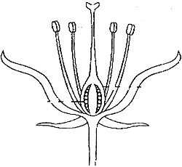

### M

**T**

* 1. Name parts marked **N** and **T**.

### N T

* 1. By use of an arrow and letter **P**, show the part that produces pollen grains.
  2. What is the main work of a flower to a plant?

1. (a) Name any **one** food we can get from these places;
2. Forests
3. Swamps
4. Rivers

(b) Give any **one** tool we can use to collect food from the river.

### Match the body organs in A to their functions in B correctly.

**A B**

Kidney stores food for some time.

Liver stores information.

Stomach produces bile.

Brain filters blood.

1. Kidney
2. Liver
3. Stomach
4. Brain
5. (a) Apart from the extended family, name any **one** other type of family in Uganda.

(b) Give any **one** role of the following people in a family.

1. Children
2. Mother
3. Write any **one** advantage of an extended family.
4. (a) What are vectors?
5. Name any **one** vector commonly found in pit latrines.
6. Give any **two** ways in which the above vector can be controlled. (i)

(ii)

### Use the words provided in the box to complete the passage below.

**sun , condensed , clouds , evaporation , water vapour**

**The water cycle.**

During rain formation, the heats water bodies like oceans, lakes, seas, rivers, swamps to cause . The

rises up to the sky and is to form nimbus clouds. The droplets of water from clouds then fall down as rain. The water flows and collects in water bodies and the cycle continues.

**Section A**

# PAPER 8

1. Name any **one** type of soil you know.
2. How does regular bathing control the spread of skin diseases?
3. Identify any **one** way strong wind can be dangerous to a crop farmer.
4. Write any **one** common accident at school.
5. How are the ears important to a person **?**
6. Give **one** way the part below is useful to a plant.



1. Why is a balanced diet needed by every person**?**
2. Identify any **one** way people take care of domestic animals at home.
3. Give **one** way water sources can be contaminated.
4. Draw and name any **one** item used to manage rainy weather.
5. How can you keep proper personal hygiene.
6. In the space provided below, draw a diagram to show air has weight.
7. Mention any **one** way mulching is useful to farmers.
8. Why do people eat food **?**
9. How is the larva stage of a butterfly dangerous to crop farmers **?**
10. Name any **one** disease spread by a housefly.

The diagram below is a garden tool. Use it to answer questions **17** and **18.**

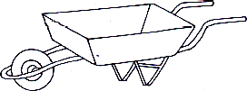

1. Identify **one** use of the above garden tool to people.
2. How can the above tool be cared for **?**
3. How do farmers benefit from nimbus clouds **?**
4. With the help of a pencil, draw an arrow to show the part used for flying.

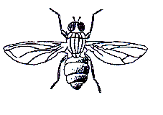

1. State any **one** reason why first aid is given to casualties .
2. Draw and name any play material made from banana fibres.
3. Identify any **one** activity a farmer carries out during the wet season.
4. How are proteins important to human bodies **?**
5. How are swamps useful to people **?**
6. In which one way do people manage sunny weather **?**
7. Mention any **one** manmade change in the environment.
8. Give any **one** danger of the animal shown below to farmers.

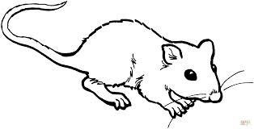

1. How are living components of soil important **?**
2. Give any **one** responsibility of a child at home .
3. Give a reason why a cow is grouped under living things.
4. How is a housefly able to spread faecal disease **?**
5. Write any **one** way you can care for the **AIDS** patients.
6. Give **one** way the sun can be used as a source of energy.
7. How are shadows formed **?**
8. In **one** sentence, write the meaning of the word transplanting **.**
9. Why is it a good practice to wash hands with clean water and soap after visiting a latrine **.**
10. Why are dehydrated people given **ORS ?**
11. Name the component of air that supports burning.
12. Identify any **one** plant that has the roots shown below.

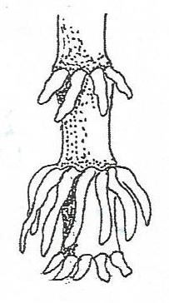

roots

**SECTION B. ( 60 marks)**

1. The diagram below shows the arrangement of soil layers. Use it to answer the questions that follow:-

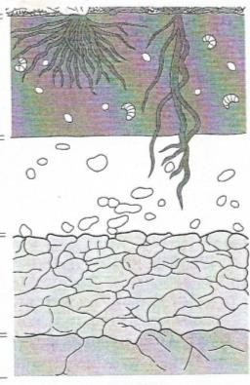

**A**

**B**

**C**

**D**

1. Name the layers marked **B** and **D**.

i) **B** ii) **D**

1. Why is layer **A** usually black and dark **?**
2. Describe any **one** way of keeping soil fertile **.**

42a) Briefly explain the term photosynthesis.

1. How is chlorophyll useful in the above process.
2. Give a reason why plants are able to carry out photosynthesis during day time.
3. Name the food that is made during the process of photosynthesis.
4. What is air **?**
5. Apart from carbondioxide, give any other two components of air.

i) ii)

1. How is carbondioxide useful in a soda factory **?**
2. The diagram below shows a fish. Use it to answer the questions

that follow. **Y**

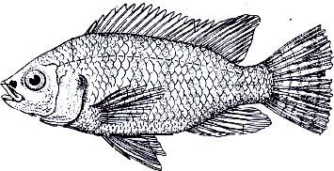

**X**

**W**

* 1. Name the parts labelled.

i)**Y** ii)**X**

* 1. How is part **W** useful to a fish **?**
  2. Name the habitat of the above animal.

1. Germination is the growing of a seed into a seedling.
   1. Write any **two** conditions needed for germination to take place.

i) ii)

* 1. Write any **one** example of a crop that undergoes the following types of germination :-

1. epigeal germination.
2. hypogeal germination.

46a) Identify any **two** items we can use to promote good sanitation at your school. i)

ii)

b) Write any **two** activities a P.4 child can do to promote sanitation at a school.

i) ii)

1. Match the garden tools to their uses correctly.

|  |  |  |
| --- | --- | --- |
| **Garden** | **tool** | **use** |
| A hoe |  | watering plants |
| A rake |  | transplanting seedlings |
| A trowel |  | pruning |

A watering can collecting rubbish

A garden tool weeding

**Garden fool use**

* 1. A hoe
  2. A rake
  3. A watering can
  4. A trowel

1. Why are bees grouped under social insects **?**
2. Apart from bees, give one other social insect.
3. How are bees useful to the following ;
4. people **:**
5. plants **:**
6. Study the life cycle below and answer questions that follow:-

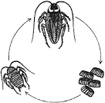

### P

* 1. Name stage marked **P**.
  2. Name the vector shown in the above lifecycle.
  3. Write **one** disease spread by the above vector.

c) How can the disease mentioned in number (**c** ) above be prevented **?**

1. Give the food value got from eating the following food stuffs.

i) fish

i) pineapple

1. Write **one** use of food to the human body.
2. Identify **one** example of food that can be preserved by smoking .

51a) What name is given to moving air**?**

* 1. Given any **two** components of air.

i) ii)

* 1. Identify any **one** danger of air.

52a) A flower is a reproductive part of a plant. Draw the female part of a flower.

1. What happens to the following parts after fertilization **?**
2. Ovary
3. Ovules
4. Why are some petals brightly coloured **?**

_ 53a) In **one** sentence , give the meaning of the term accident.

1. Give any **two** causes of accidents on Ugandan roads.

i) ii)

1. Mention **one** way in which the above causes can be prevented .

54a) Write any **two** causes of soil erosion.

i) ii)

1. How can erosion be controlled in a garden **?**

i) ii)

55) **The steps below shows a wrong order of making O.R.S. Rearrange them correctly.**

1. Stir the mixture until it the solutes dissolve.
2. Measure 1 litre of drinking water into a clean container.
3. wash your hands with clean water and soap.
4. Measure eight levelled tea spoonfuls of sugar and one of salt into the container.

# PAPER 9

### SECTION A:

1. Name any **one** dicotyledonous plant commonly grown for food.
2. How is photosynthesis in plants useful to animals?
3. Give any **one** way you can improve soil fertility in the school garden.
4. Write the importance of washing mango fruits before eating them.
5. Identify any **one** danger caused by strong wind.
6. Which mosquito spreads malaria germs?
7. Why should a rain gauge be placed in an open place?
8. Give any **one** way you can care for your tongue.

### The diagram below shows a nursery bed. Use it to answer question 9.

**W**

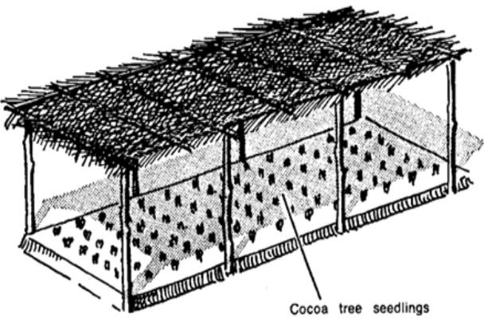

1. How is part marked **W** important on a nursery bed?
2. In which way can electricity be dangerous to people?
3. Write **one** activity you can carry out to reduce houseflies at home.

[**ng.com**](http://www.tekartlearning.com/)

1. Name the male reproductive cells of a flowering plant.
2. How can a farmer increase the proper working of the garden tool below?

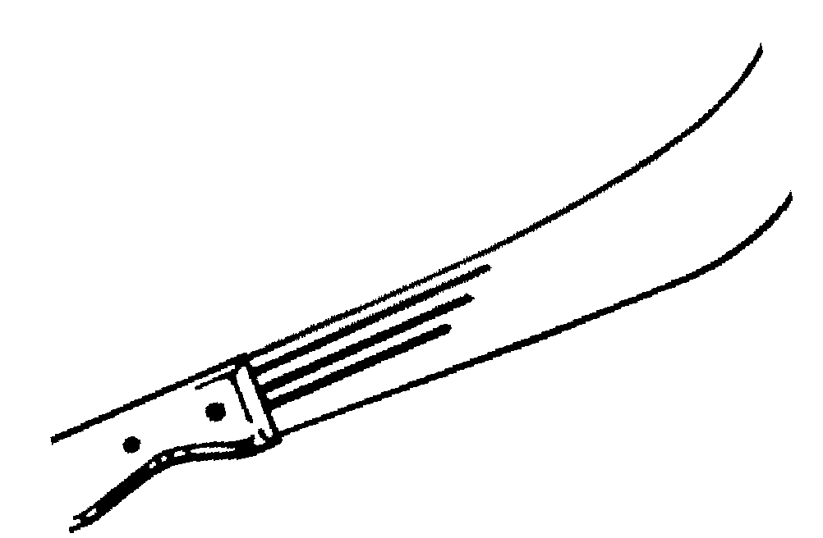

1. Identify the body sense responsible for finding out the sweetness of juice.

### Draw a diagram of a simple leaf in the space below.

1. Give any **one** danger of electricity at home.
2. Name any **one** animal whose habitat is a burrow.
3. Write any **one** way you can protect yourself from coldness on a rainy day.
4. Give **one** way in which plants can reduce the rate of transpiration.

### The diagram below shows a fish. Use it to answer question 20.



[**www.tekartlearni**](http://www.tekartlearning.com/)

**Page 77**

1. Use letter **P** to show the part used to detect sound waves in water.
2. Why is it important for us to bathe daily?
3. What is the danger of having bushes near our homes?
4. Give **one** reason why bees visit flowers.

### The diagram below shows a common plant. Use it to answer questions 24 and 25.

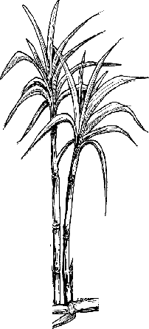

**X**

1. Name part marked **X** on the plant above.
2. Identify the common product that can be got from the plant above.
3. How can people protect themselves from worm infestation?
4. Why do some Ugandans keep ducks at their homes?
5. Give **one** human activity that destroys habitats of wild animals.
6. What is the danger of throwing stones at a bee hive?
7. Which food value prevents kwashiorkor in children?
8. Give **one** way of preserving food for a long time.
9. In which way is the water cycle important in our environment?
10. Write **one** crop growing practice which adds humus to the soil.
11. Name the non-curable disease which can be spread through sharing body piercing tools.
12. Which element of weather provides heat to people?

### The diagram below shows an insect. Use it to answer questions 36 and 37.

1. Which st shown above?

age of the life cycle of an insect is

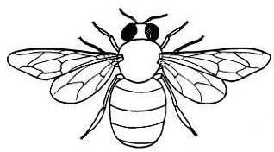

**M**

1. What danger will the insect have if parts marked **M** are blocked?
2. How are wild animals dangerous to people?
3. Give any **one** thing that is given to patients in a hospital.
4. Name **one** domestic animal that gives us a lot of milk.

### SECTION B

1. (a) Identify any **two** materials that can be used to build a permanent house.

(i)

(ii)

* 1. Why do people build houses?
  2. Give any **one** way of caring for a house.

1. (a) Give the use of these tools during first aid. (i)

(ii)

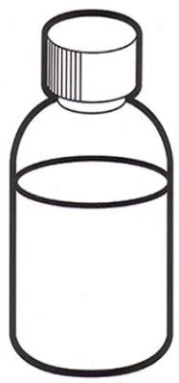

**spirit**

1. How is first aid useful to casualty?
2. Give **one** quality of a good first aider.
3. (a) What is harvesting?
4. Why is the dry season the best for harvesting seed crops?
5. How can a farmer prevent rats from destroying his crops in the granary?

### Draw and name any one garden tool used for harvesting crops.

1. (a) Give any **one** different way soil may be useful to termites and people.
   1. Termites
   2. People
2. Name **one** organism that helps in soil formation by decomposition.
3. Which component of soil is needed by plants during photosynthesis?
4. (a) Why should people observe proper personal hygiene?
5. Give the use of these materials in promoting personal hygiene.
6. soap
7. towel
8. Identify any **one** disease that people can get due to poor personal hygiene.
9. (a) Write any **one** way non- flowering plants reproduce.
10. Give **one** example of non-flowering plants.
11. How are non-flowering plants useful to people? (i)

(ii)

### The diagrams below show things we make at home.

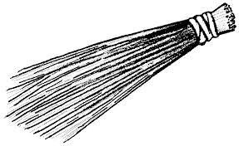

**A**

**B**

1. Give the use of each of the items above.

### A B

1. Write **one** material used to make item (**B**) above.
2. How can a P.4 pupil benefit from making the items above?

_

1. (a) Write **two** activities that can lead to contamination of water sources.

(i)

(ii)

1. Why is it dangerous to drink contaminated water?
2. How can water be made safe for drinking?

### Study the diagram below and use it to answer question 49.

**+ + =**

**solution**

**1 tea spoonful of salt**

**8 tea spoonfuls of sugar**

**1 litre of drinking water**

1. (a) Name the solution made above.
2. How is the solution above useful to people?
3. Give the reason why the following are necessary in the above solution
4. salt
5. sugar
6. (a) Give any **two** ways in which insects spread germs to people. (i)

(ii)

1. Apart from insects, give any other disease vector.
2. How are vectors different from pests?
3. (a) Write any **one** use of food in the body.
4. Why do children need a lot of proteins in their diet?
5. Which class of food is most needed by brick makers?
6. Give **one** sign of poor feeding among children.

### The diagram below shows weather instruments.

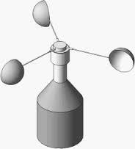

**A**

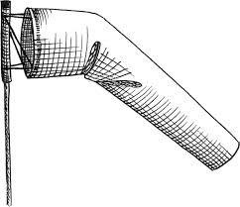

**B**

1. Name the instruments shown above.

### A B

1. Which element of weather enables the instruments above to work?
2. How are the above instruments similar?
3. (a) Which system of a flowering plant develops from the radicle?
4. State the function of these parts to a germinating bean seed.
5. micropyle
6. cotyledon
7. Identify any **one** factor that can fail a seed to germinate.

### Match the body organs to their correct functions.

**Body organ Function**

* 1. Heart - regulating blood sugars
  2. Kidney - storing information
  3. Brain - pumping blood
  4. Liver - filtering blood

1. Heart -
2. Kidney -
3. Brain -
4. Liver -
5. (a) How are shadows formed?
6. At which time of the day is the shadow shortest?
7. Give **one** use of shadows to children.
8. Draw the shadow for the object below.

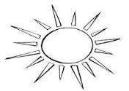

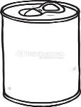

# PAPER 10

### SECTION A:

1. Which element of weather do people use for winnowing?

_

1. State any **one** way of keeping water sources clean.
2. How are feathers useful to a bird?
3. Identify the deficiency disease caused due to lack of vitamin C in the diet.
4. Name **one** crop that can be harvested using the garden tool below.



1. How can a P.4 child protect him/herself from getting HIV/AIDS?

### The diagram below shows part of a flower.

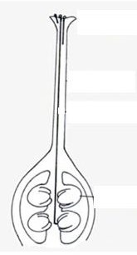Use an arrow and letter **N** to show the part that receives pollen grains.

### _

1. Give any **one** way of keeping your beddings clean.
2. Why are farmers advised to leave enough space between rows when planting?
3. State any **one** danger of wild birds to people.
4. How is poor personal hygiene dangerous to people?
5. Identify any **one** human activity that can change the environment.

### Draw a diagram of a simple leaf and show the midrib.

1. How do you care for your eyes?

### The diagram below shows a child suffering from a common disease.

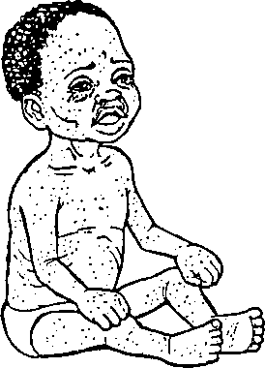

1. How can the disease in the child above be prevented among children?
2. Which gas is needed by plants during photosynthesis?
3. What first aid can be given to a person with a burn?
4. Name **one** harmful insect in the environment.
5. Give any **one** way of controlling pests in a maize garden.
6. Write any **one** use of food in the body.
7. Which part of a seed grows into the root system?
8. Give **one** way of managing rainy weather.
9. How are claws useful to a cat?
10. Why do people close windows and doors early in the evening?
11. State **one** sign of food poisoning in people.
12. How are earthquakes dangerous to people?
13. Give **one** use of very heavy clothes to people who wear them.
14. Identify any **one** way of preserving groundnuts after harvesting?
15. How can a P.4 pupil avoid having a bad breath?
16. Write **one** type of germination.
17. Why are pain killers important to a casualty?
18. Give **one** way of controlling soil erosion in a compound.

### The diagram below show a tapeworm. Use to answer question 33.

**P**

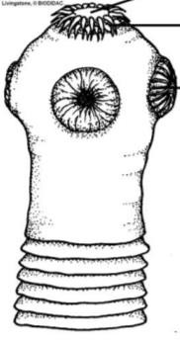

1. How are the structures marked **P** useful to a tapeworm?
2. How is a nest useful to a bird?
3. Apart from drinking water, name **one** other item used in the preparation of ORS locally.

_

1. What is the danger of cutting down trees on a large scale in an area?
2. Name any **one** insect without wings.
3. Write down any**one** product of a cow that gives us proteins.
4. How are tree shades useful to people?
5. Why is a tsetse fly grouped under vectors?

### SECTION B

1. a) Give the difference between wind and air.
   1. Write any **one** importance of wind to a crop farmer.
   2. How are the following gases useful to people?
2. Oxygen
3. Carbon dioxide

### The diagram below shows vertical arrangement of soil layers. Use it to answer the questions that follow.

**B C**



* 1. What name is given to the above vertical arrangement of soil layers?
  2. Name any **one** organism found in layer **B**.
  3. Identify layer marked **C**.
  4. Where can we observe the above arrangement in the environment?

1. a) Write any **two** diarrhoeal diseases spread by houseflies.

4. How can the above diseases be controlled in a community?
5. How are diarrhoeal diseases dangerous to people?
6. a) What is sanitation?
7. Give **one** importance of maintaining proper sanitation in an area.
8. Write **two** activities you can do to keep your classroom clean.

### The diagram below shows a food store. Use it to answer question 44.

**M**

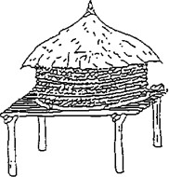

**L**

1. Name the food store shown above.
2. Identify any **one** example of a crop kept in such a store.

_

1. Write the importance of part marked **L** and **M** on the store above.

### L M

1. a) State the function of each of the following types of teeth.
2. Canines
3. Incisors

b) Give **two** ways of keeping our teeth healthy.

3. a) In which way is heavy rainfall dangerous to people?
4. Give **two** processes involved in rainfall formation.

7. How is the sun important in the process of rain formation?

### The diagram below shows a life cycle of an insect. Use it to answer the questions that follow.

**B A**

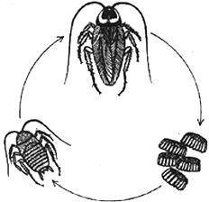

**C**

1. What do we call the stage marked **C** on the diagram above.
2. Name the type of life cycle shown above.
3. Identify **two** insects that undergo the life cycle above.

### Complete the table below correctly.

|  |  |
| --- | --- |
| **BODY ORGAN** | **FUNCTION** |
| Heart |  |
|  | To filter blood. |
| Brain |  |
|  | To taste food. |

1. a) What is a nuclear family?
2. Apart from parents and their own children, name **one** other person found in an extended family.
3. Give **two** roles of parents in a family.

6. a) Write any **one** dangerous object found on roads.
7. Name any **two** groups of people who help in traffic.

10. How can road accidents be controlled in our district?

### The diagram below shows part of the human body.

**N**

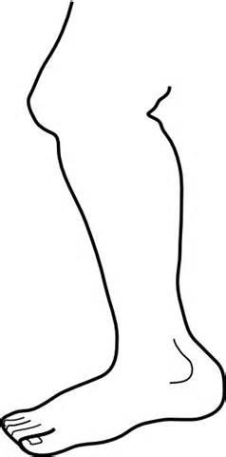

**K**

* 1. Identify the parts marked **N** and **K**.

### N K

* 1. Name the part of the human body shown above.
  2. How can you care for the above part of the body?

1. a) Write **two** ways of keeping soil fertile.

b) Identify any **two** activities that can make soil lose its fertility.

2. _
3. a) Why do animals move from one place to another?

b) Give **two** ways animals care for their young ones.



d) In which way are wild animals dangerous to crop farmers?

### Match the types of mosquitoes to the diseases they spread.

* 1. Female anopheles mosquito Elephantiasis
  2. Tiger mosquito Malaria
  3. Culex mosquito Yellow fever

1. Female anopheles mosquito
2. Tiger mosquito
3. Culex mosquito
4. Give **one** way of controlling the spread of the diseases above.
5. Name **one** cereal crop.

# PAPER 11

### SECTION A:

1. Why do farmers mulch their gardens?
2. Name **one** food stuff which can be preserved by smoking.
3. Why is it important to iron clothes after washing?
4. What is the importance of a rain gauge at a weather station?
5. How is ORS useful to a dehydrated person?

_

1. Why are wasps grouped under social insects?
2. Name **one** raw material plants need to make their own food.
3. Why should P.4 children wear shoes in school?
4. How are children protected from measles?
5. Why do children make materials like mats and baskets?
6. Write **one** cause of accidents on the road.
7. 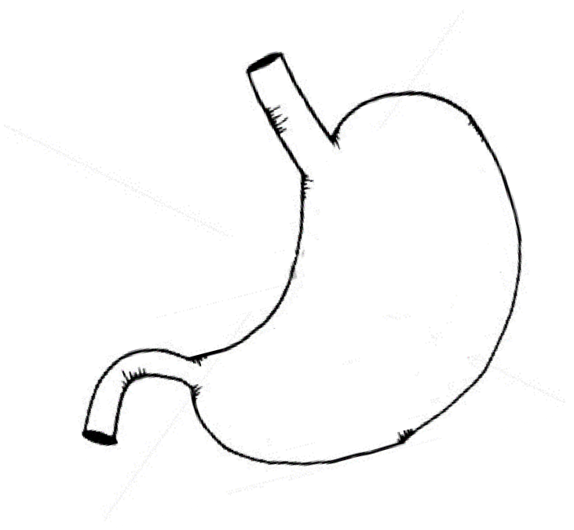Give **one** function of the organ below.
8. Write **one** product made from animal hides.
9. How does the sun contribute to the formation of rainfall?
10. Why do bees visit flowers?
11. Draw a canine tooth in the space provided.
12. Why are monkeys grouped under pests?
13. State any **one** danger of wind.
14. How is yellow fever spread among people?
15. Which component of air supports burning?
16. Why do some people harvest rain water?
17. How is chlorophyll important to plants?
18. Give **one** item used to promote oral health.
19. How are gills useful to a fish?
20. State **one** way farmers in hilly areas control soil erosion.
21. Why are people advised to bathe regularly?
22. Give **one** danger of poor feeding to people.
23. How dangerous is it to live with domestic animals in the same room?
24. Why can’t mushrooms make their own food?
25. Why is breast milk the best food for babies?
26. How is the animal below useful to people at home?

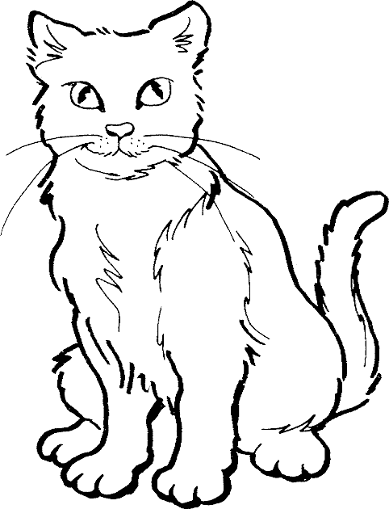

1. Why would a cockroach die it its abdomen is kept in water for some time?
2. Which type of soil holds water for the longest time?
3. Write **one** natural habitat of wild animals.
4. Why do chameleons change colours?
5. Which set of teeth is found in the mouth of a four year old boy?

### Draw any one item used to give first aid to a casualty.

1. Why should people eat food containing all food values every day?
2. Name the part of a plant that sucks water from the ground.

### SECTION B

1. (a) Name any **two** examples of insects which cannot be eaten.

(b) Write any **two** insects without wings.

3. (a) Briefly explain the term soil erosion.
4. Write down **two** agents of soil erosion.

7. How is soil erosion dangerous to soil?
8. (a) Why do people drain swamps in the environment?

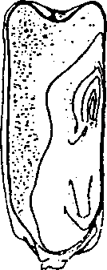

**M**

**N**

**O**

1. Write down **one** effect of the following human activities in the environment.
2. swamp drainage
3. over grazing
4. Give **one** way of controlling floods in the environment.

### Below is a maize grain, use it to answer questions that follow.

|  |  |  |
| --- | --- | --- |
|  | (a)  **M** | Name the parts marked **M** and **N**. |
| **N** |  |
| (b) | How is part marked **O** useful to a maize grain? |
| (c) | Why is the maize grain above classified under fruits? |
| 45. | (a) | Give any **one** way HIV/AIDS is spread among people. |
|  | (b) | How can a pupil protect him/ herself from HIV/AIDS? |
|  | (c) | Give **one** danger of HIV to people. |
|  | (d) | Write **one** way of caring for HIV/AIDS patients. |
| 46. | (a)  (i) | Name any **two** artificial sources of light. |

(ii)

1. Give **one** example of an item which uses electricity to work.
2. Give **one** importance of saving energy at home.

### Below is a life cycle of a vector. Use it to answer questions that follow.

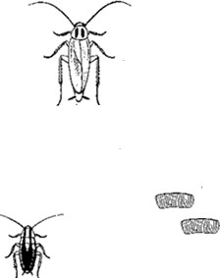

**A**

**B**

**C**

* 1. Name the stages **A** and **C** in the above life cycle.

### A C

* 1. Name **one** disease spread by the above insect.
  2. How can we control the spread of the disease you have named in (a) above.

### Match the following animals in A to their habitats in B. A B

* 1. dog - hutch
  2. man - water body
  3. fish - house
  4. rabbit - kennel

1. Dog
2. Man
3. Fish
4. Rabbit
5. (a) Write any **one** root system in plants.
6. Give **two** uses of roots to a plant.

9. Which part of a bean seed develops into a root system?
10. (a) Give **one** reason why farmers mulch their gardens.
11. Name any **two** materials used for mulching.

14. Give **one** way in which mulching may be dangerous in the garden.

### Below is an experiment carried out by a P.3 class.

**s**

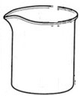

**glas**

**water**

**Air bubbles**

**dry lum**

**p of soil**

* 1. What does the above experiment show about soil?
  2. Apart from air, write **two** other components of soil.

2. 1. How is air useful in soil?
3. (a) Name the element of weather which is got from nimbus clouds.
4. How is the element named in (a) above useful to a crop farmer?
5. Give **one** danger caused by too much sunshine in our environment.
6. How can the danger given above be managed?

### (a) Draw the garden tool used for the following activities in the garden.

|  |  |
| --- | --- |
| Harvesting root crops | Watering crops |
|  |  |

1. Give **one** way a slasher can be dangerous to the person using it.
2. How can **one** take care of a slasher?
3. (a) Define the term “personal hygiene”.

`

1. Name any **two** activities which are used to keep our hair neat and clean.

(i)

(ii)

1. Give **one** importance of maintaining proper personal hygiene.

|  |  |  |
| --- | --- | --- |
| 55. | (a) | Name the vector involved in the 4Fs cycle. |
|  | (b) | Identify **two** diseases spread through 4Fs. |
|  | (i) |  |
|  | (ii) |  |
|  | (c) | Give **one** way of controlling the spread of diseases by the insect |
|  |  | Vectors in (a) above. |

**SECTION A**

# PAPER 12

### Name any one material that can be used to build a house.

1. **How is a pit latrine useful in a home?**

### Draw the human body part used for seeing.

1. **How do most flowering plants reproduce?**

### State any one way clouds are useful to people in the environment.

1. **Suggest one way you would prevent garden tools from rusting.**

### How can people control soil erosion in a school compound?

1. **Name any one object that can cause wounds.**

### Draw a diagram to show epigeal germination.

1. **How can an individual manage sunny weather?**

### Why should pedestrians cross a busy road at a zebra crossing?

1. **Suggest any one way people can care for domestic animals.**

### How is too much sunshine dangerous to a crop farmer?

1. **In which one way can you control the spread of malaria at home?**

### State any one way school children use water.

1. **Give one importance of food to the body.**

### Why do you clean your body using soap?

**The diagram below shows an insect. Use it to answer the question 18.**

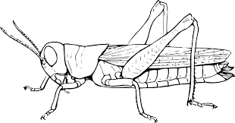

### Name the insect above.

1. **Write any one use of plants to animals.**

### Why should people wash fruits before eating them?

**The diagram below shows a soil profile. Use it to answer question 21.**

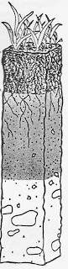

### Use an arrow to label the sub soil.

1. **Why is it important to keep water sources such as wells clean?**

### Identify any one way a farmer can control pests in a maize garden.

1. **How can you use banana fibres at home?**

### Name the crop growing practice where unwanted plants are removed from the garden.

1. **State the type of soil used for making pots.**

### How can a P.4 child keep his/her finger nails clean?

1. **Give any one use of trees found in the school compound.**

### Identify the component of soil that plants use during photosynthesis.

1. **How do crop farmers use rabbit droppings?**

### State any one danger of electricity at home.

1. **How can you prevent meat from going bad?**

### Name the method you can use to control cockroaches at home.

1. **Why is too much sunshine dangerous to crop farmers?**

### Draw and name one animal that lives in water.

1. **Give any one source of food.**

### State any one use of stones to people in our community.

1. **How do parents protect their children from polio?**

### Identify any one farming activity commonly done during a wet season.

**The diagram below shows a banana plant.**

**A**

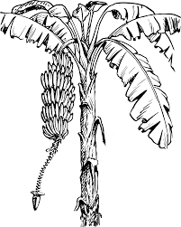

### Of what use is part marked A to people?

**SECTION B**

### (a) Name any two conditions necessary for rusting to take place.



### 

* 1. **How can people prevent their tools from rusting?**

### Write down one danger of rusting.

1. **(a) What is pollination?**

### State the two types of pollination.



### 

1. **Name the bright coloured structures that attract pollinators in flowers.**

### The experiment below was carried out by P.3 pupils. Use it to answer the questions that follow.

**Candle lighting**

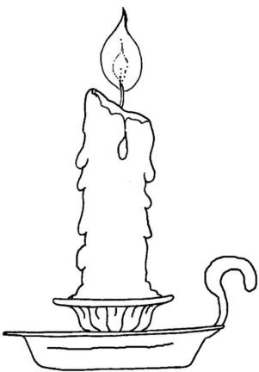

**Candle went off**



### A B

1. **What is the experiment about?**

### Why did the candle go off in B?

1. **Which gas is produced as the candle burns in A?**

### Give any one use of fire to people.

1. **Using the diagram below answer the questions that follow.**

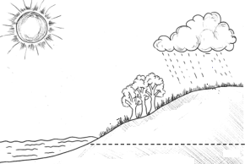

**Sun**

**B**

**A**

**Water**

### Name the processes marked A and B on the diagram.

**A B**

### What is the importance of the sun in the process above?

1. **What scientific name is given to all the processes given above?**

### (a) Name any two classes of food.



### 

1. **Give any two dangers of poor feeding to a child.**

### 



### (a) Which local materials are used to make these items?

* 1. **ropes**

### mats

1. **Identify the tools used for the following activities;**

### sweeping

* 1. **slashing**

### (a) Write any two examples of useful insects.



### 

1. **Give any one example of harmful insect.**

### How can people care for useful insects?

1. **(a) What are perennial crops?**

### Mention any two examples of perennial crops.



### 

1. **Why would you classify simsim as an annual crop?**

### (a) Draw and name two items found in a first aid box.

|  |  |
| --- | --- |
|  |  |
|  |  |

1. **Why should accident victims be given first aid?**

### How can people control and prevent accidents at home?

1. **(a) State any two examples of domestic birds.**

### 



### Write any two things people get from domestic birds.



### 

1. **(a) Draw the garden tools used in carrying out the activities below.**

### weeding (ii) cutting trees

1. **State any two ways of caring for garden tools.**

### 



### (a) How is the sun important to people?



### 

1. **Give any one importance of shadows to people.**

### State one danger of the sun.

1. **(a) Give one importance of a sick bay at school.**

### Name any one group of people who work in a sick bay.

1. **Identify any one material found in a sick bay.**

### Name any one place in your community which has a similar function as a sick bay.

1. **(a) What is personal hygiene?**

### State any one danger of poor personal hygiene.

1. **What can you do to promote personal hygiene?**

### 



### Match the vectors with the disease they spread. Vectors Diseases

**Female anopheles mosquito diarrhoea. Tsestse fly river blindness**

### Black fly malaria.

**Housefly sleeping sickness.**

### Female anopheles mosquito Tsestse fly

**Black fly**

**Housefly**

# PAPER 13

### SECTION A: 40 MARKS

1. Give any **one** example of a dicotyledonous seed.
2. Name any **one** domestic animal that gives us milk.
3. Give any **one** component of soil.
4. State any **one** importance of shadows to people.
5. Name any **one** material used to make a kite used for playing.
6. Why do we iron clothes?
7. Name any **one** place where harvested crops can be stored.
8. In the space below draw an item used to keep our bodies clean.
9. Why is a maize grain called a fruit?
10. What is wind?
11. Name the plant fibre used for making balls.
12. Apart from cirrus, name any other type of clouds.

### The diagram below shows a root system, use it to answer questions 13 and 14.

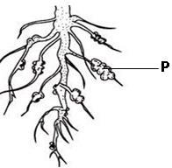

1. Name the root system drawn above.
2. Name any **one** example of a plant with the above type of root system.
3. What do we call the young plant in the garden?
4. Give any **one** way in which some plants climb others.
5. How do flowering plants reproduce?
6. What does the experiment below show?

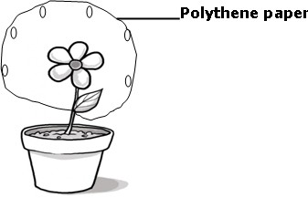

1. Name any **one** common accident at home.
2. Name the sanitation material we use for putting on plates to dry.
3. Mention any **one** natural change in the environment.
4. Give any **one** way of caring for our teeth.
5. Mention any **one** type of soil.
6. Name the type of leaf shown in the diagram

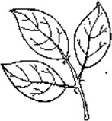

1. How is a dog important at home?
2. Why are beans called annual crops?
3. Give any **one** use of leaves to plants.
4. Name any **one** activity done to clean our bodies.
5. What are pests?
6. Name the structure drawn in the diagram below.

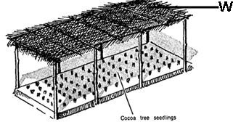

1. What type of germination do beans undergo?
2. Mention any **one** method used in growing plants.
3. State any **one** danger of wind.
4. What name is given to a male part of a flower?
5. Why are people encouraged to boil water for drinking?
6. State any **one** importance of a dust bin in your classroom.
7. Name any **one** insect that protects itself by stinging.
8. Name any **one** type of leaf venation.
9. Name any **one** place where houseflies lay their eggs.
10. Give any **one** use of plants to people.

### SECTION B: 60 MARKS

***Questions 41 to 55 carry four marks each***

1. (a) What is seed germination?
2. Give **two** conditions needed for seeds to germinate.

5. Mention any **one** type of germination.
6. (a) What is personal hygiene?
7. Give any **two** ways of promoting personal hygiene.

10. State any **one** danger of not promoting personal hygiene.

### The diagram below shows a flowering plant. Use it to answer question 43.

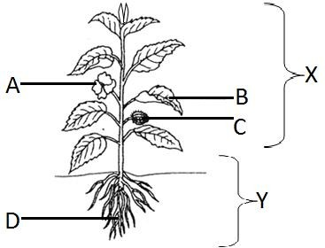

1. (a) Name parts marked **A** and **C**

### A

* 1. **C**

(b) Name the systems of a plant marked **X** and **Y**.

### X

1. **Y**
2. (a) Give **two** examples of pests which attack crops in the garden.
3. Mention any **one** way of controlling pests in the garden.
4. Mention any **one** disease of crops.
5. a) Name any **two** crops grown in a nursery bed.
   1. (ii)
6. Give any **one** way of caring for crops in a nursery bed.
7. Why is transplanting of seedlings done in the evening?
8. (a) Mention any **two** crop growing practices.

(b) Give any **two** examples of leafy vegetables.



### The diagram below shows a flower. Use it to answer question 47.

1. (a) Name parts marked **W** and **Y**

### W

* 1. **Y**

1. What does part **Z** develop into after fertilization?
2. State any **one** importance of flowers to people.
3. (a) What is pollination?
4. Give any **two** types of pollination.

7. Which insect pollinates flowers at night?
8. (a) What are perennial crops?
9. Give any **two** examples of perennial crops.

12. Name any **one** method used to harvest perennial crops.
13. (a) What name is given to the food made by plants during photosynthesis?
14. Give **two** raw materials needed by plants to make their food.

17. Mention any **one** condition needed by plants to make their own food.
18. The table below shows types of weather in **A** and activities done in **B** in a wrong order.

|  |  |
| --- | --- |
| **A** | **B** |
| Rainy weather | Winnowing seeds |
| Windy weather | Drying harvested crops |
| Sunny weather | Harvesting water |

Write the correct activities from the table done during;

* 1. Rainy weather :
  2. Windy weather :
  3. Sunny weather :

(b) Which of the above weather can be managed by putting on gumboots?

1. (a) Give any **two** types of stems
2. Mention any **two** uses of stems to people.
3. a) Mention any **two** sources of water.
4. Give any **one** use of water at home.
5. Write down any **one** way of making water safe for drinking at home.
6. (a) What is air?
7. Mention any **two** gases found in air.
9. _
10. State any **one** property of air.
11. a) Name the garden tools below.

|  |  |
| --- | --- |
|  |  |
|  |  |

1. Give any **two** ways of caring for garden tools.

# PAPER 14

### SECTION A

1. Name **one** body organ used for hearing.
2. Give the suitable time for transplanting seedlings.
3. What is personal hygiene?
4. Write down **one** disease of the teeth.
5. Why is it good to plant trees in the compound?
6. How can a P.4 pupil protect his food from contamination?
7. Name the type of leaf shown below

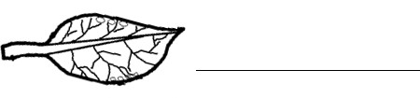

1. State **one** item used to promote sanitation.
2. Write down the cause of night blindness in people.
3. Which vector spreads cholera?
4. What is an accident?
5. Name the type of germination the maize grain undergo.
6. State any **one** type of blood.
7. Give any **one** example of diarrhoeal diseases?
8. Write down **one** raw material for photosynthesis.
9. List down **one** use of food in the body.
10. Which mineral salt is needed in the body to prevent anaemia?
11. Name the type of tooth shown below.



1. What is sanitation?
2. Why do plants with weak stems climb others?
3. How do we call the green colouring matter in the leaf?
4. Write S.S.S in full.
5. Give **one** common accident at school.
6. Name any **one** animal protein.
7. State any **one** way a P.4 pupil can promote oral health.
8. What is a germ?
9. Give any **one** way we keep our bodies clean.
10. Name the part marked Y on the root below;

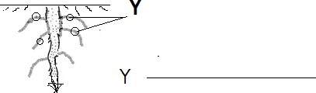

1. State the importance of roots to the plants.
2. Why does blood go to the lungs?
3. Give **one** sign of goitre.
4. Write **one** danger of poor sanitation in the environment.
5. How are carrots propagated?
6. Write **one** example of a non-communicable disease.
7. Which body organ protects the brain?
8. How do tape worms enter our bodies?
9. Name **one** disease that can be got due to poor personal hygiene.
10. How do we call a female part of the flower?
11. The nose is to people while is to leaves.
12. Name **one** place where germs are got.

**SECTION B (60 Marks)**

1. (a) What is pollination?
2. State any **one** type of pollination.
3. Name the insect that pollinates flowers at night.
4. What helps the insect named above to reach the flowers at night?
5. a) Why do we wash our hands with soap after visiting the latrine?
6. Give **one** reason why finger nails should be kept short.
7. List down **two** items used to promote personal hygiene.

   2. 43 (a) Why do people eat food? **(Give four reasons)**



12. (a) What is germination?
13. How is rusting similar to germination?
14. Give the function of water during germination.
15. Write down **one** factor that can lead to seed dormancy.
16. Match the classes of food and the diseases below;

|  |  |  |  |
| --- | --- | --- | --- |
|  | **Food** |  | **disease** |
| (i) | Proteins |  | Night blindness |
| (ii) | Vitamin B**1** |  | Rickets |
| (iii) | Vitamin D |  | Kwashiorkor |
| (iv) | Vitamin A |  | Beriberi |
| (i) | Proteins | : |  |

|  |  |  |  |
| --- | --- | --- | --- |
| (ii) | Vitamin B**1** | : |  |
| (iii) | Vitamin D | : |  |
| (iv) | Vitamin A | : |  |

1. Write 4Fs in full.
2. (a) What is dehydration?
3. Give **one** sign of a dehydrated person.
4. Why is ORS given to a person with severe burns?
5. How is sugar in ORS solution important to a dehydrated person?
6. (a) Name the body part that protects the lungs.
7. Give **two** functions of the brain.
8. Write the vector that spreads trachoma to people.

49(a) How is a dust bin important in a classroom?

1. Give any **two** activities done to promote sanitation.
2. List down **one** quality of a hygienic home.

50(a) Write the 3Ds in full.



b) Give any **one** way we can prevent typhoid in our homes.

1. a) Apart from brushing the teeth, give any two ways we can care for our teeth.
2. How are canine teeth important to dogs?
3. Name **one** set of the teeth.

52(a) What is weather.

1. How is sunny weather important to a farmer?
2. Write down **two** elements of weather.
3. 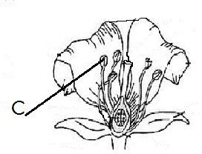The diagram below is of a flower. Use it to answer the following questions.
   1. Using letter A, show the part of a flower that develops into a fruit.
   2. Name part marked **C.**
4. Give **two** functions of a flower to man.

   2. 54(a) What is transpiration?
5. Give **two** factors that can affect the rate of transpiration.
6. How is transpiration important to a plant?

55. (a) Name the type of air that supports burning.

1. How is wind important in the environment?
2. List down any **two** projects you know.